 | Christian Worldviews  (Or use some selected Understanding Christianity units as  appropriate) |  |  | Religious and non-religious Worldviews *  (Schools to choose range of religions and worldviews  according to Locally Agreed Syllabus or MAT syllabus)
Year  group | Beliefs &  Questions  (Theology) | Community &  Identity  (Human & Social Science & History) | Reality and truth  (Philosophy) | Beliefs &  Questions  (Theology) | Community &  Identity  (Human & Social Science & History) | Reality and truth  (Philosophy)
Reception | Who are Christians and what do they believe?  Focus on some of the stories from the Bible that show what Christians believe. Establish that Christians live all over the world.  What is the church and who goes there?  Variety of church buildings and the things that happen in a church. Find out about vicars and bishops.  Look at Sundays, seasons, and festivals.  Who am I and where do I belong?  Explore the different groups that people belong to, including  the religious ones. Find out about Christian signs of belonging |  |  | Does everyone believe in God? What do people celebrate and why? Are all families the same?  Each of these questions takes one of the themes form the Christian units and expands on them from a multi-religious and multi-secular perspective. These and the Christian units can and should be woven through continual provision.  At EYFS the divisions between the themes are less emphasised and the philosophical elements are woven through all units
NSE* | This will largely be up to teachers to include as appropriate to their setting.
UC  options | All three UC units for FS2 could be taught here instead of the  scheme units.
Year A  Lower School  Monkey  Lemur | Why do most Christians call God ‘creator’?  Genesis 1 – 2,  Psalms 8, 19 etc. Link to care for creation. |  |  | What do different Jewish people believe about God? God as creator, choosing Abraham; rescuing them and also the Shema; cultural/secular Jewish people with no belief. | How and why is Shabbat important to some Jewish people in Britain? Shabbat laws and rituals and the ways that it separates them from but unites them. Link to God as Creator and day  of rest | How do people know how to behave?  Focus on 10 commandments and Jewish food laws; also look at different days of rest in different religions. Introduce the Golden Rule. introduce another worldview; Sikhi.

NSE* | a, b, d, g, i, j |  |  | a, b, f, g, i | a, b, c, e, h, i | b, e, f, i, j, k
UC Units |  | UC 1.5 Why does Easter matter to Christians? | UC1.4 What is the good news that Jesus brings? (CORE)
Year B  Lower School | How do Christians find out what God is like?  Explore the character and attributes of God and Jesus as revealed through the Bible, both Old and New testaments, God as Father, Son and Spirit. |  | How do Christians decide what is right?  Explore the role of conscience, leaders and teachers in interpretation Focus on authority of text, person and place, testing whether ideas make sense. | What does Torah mean for Jewish people?  Look at scroll, understand what is in there, rules and stories, history of the Jewish people. In Hebrew, sacred language for prayers | In what ways is the synagogue important to Jewish people?  Central place of community to come together for learning, fellowship, prayer, and service. Place to store Torah. | What are the best reasons for following a leader? Focus on authority of text, person and place, testing whether ideas make sense and testing their reliability.
NSE* | a, b, d, g, i, j, k |  | a, b, c, e, f, g, j, k | a, b, d, f, g, j | b, f, h, i | d, e, f, g, i, j, k
UC |  | UC 1.5 Why does Easter matter

 |  | to Christians?
Year C  Lower  School | How are different people inspired by the teachings of Jesus?  Concept of Gospel and explore how Jesus treated people – discipleship, followers, love. |  |  | What do Muslims believe about God and where did Islam start?  Tawhid, Muhammad, Night of Power, monotheism in a polytheistic culture. 99 names of Allah. | What is the Qur’an and why do many Muslims try to learn it by heart? Angel Jibril dictated the very words of God; therefore, they are important. Use Arabic and become Hafiz. | Does it matter if a story is true or not?  Focus on deeper truths, perception and evidence.  Explore proverbs and sayings, including non- religious ones.  This could begin to bring in real philosophy, such as  Plato’s cave
NSE* | a, b, f, g, h, i, j |  |  | a, b, c, f, g, i | a, b, g, h, j | c, d, e, f, i, j, k
UC |  | UC2a.5 Why do Christians call the day Jesus died  ‘Good Friday’? (C) | UC2a.6 When Jesus left, what was the impact of  Pentecost?
Year A  Upper School  Jaguar  Toucan |  | How and why has Christian practice changed over time?  Early church was Jewish and as more  non-Jews were | Does prayer make a difference and how do Christians know?  Find out what Christians pray  (e.g., Lord’s prayer) | How do Hindus understand God (Brahman)?  One God in many forms, God in everything, part of  everything, | What role does worship play in the life of a Hindu?  Arti and Puja, home shrine and Mandir, ritual and  celebrations. | How and why do people argue that some places can be spiritual?  Focus on Christian and Hindu beliefs  about spiritual

 |  | added adaptations happened; Christians believe God still speaks, role of sanctified common sense.  Perhaps include story of Peter at the house of Simon  the Tanner Acts 10. | and explore what people do because they have prayed. How does prayer change things for a Christian? | different symbols for the attributes of God – and some of the stories linked to Vishnu, Shiva, Ganesha etc. |  | places, but also the fact that for some people place  doesn’t matter. This will bring in the philosophical concept of whether spirit resides in people, or places  or doesn’t exist.
NSE* |  | b, c, f, g, h, i, j | a, b, d, e, h, j, k | a, b, c, f, g, h, i, j | a, b, c, f, g, h, j, k | b, d, h, i, j, k
UC | UC2a.3 What is the Trinity?
Year B  Upper School | What do Christians believe about the death of Jesus?  Crucifixion, salvation, sin, atonement, focus on Good Friday. Also see that Jesus predicted his death and consider how he understood it |  | Does wisdom look the same for everyone?  Define wisdom and knowledge. Explore the way the Bible teaches wisdom, using explicit teaching, proverbs and parables. | Why is it important to Muslims that Muhammad is known as the seal of the prophets?  Find out about the Muslim view of the prophets of the Old Testament, Jesus, and the role the Muhammad plays in the concept of  Prophethood | How far does the mosque contribute to the Muslim concept of Ummah?  Understanding the worldwide community of Islam, and the role of the mosque.  Explore other ways that ummah is  expressed | What does it mean to live a good life? Ensure that non- religious views are considered here too.  Bring in The Phillipa Foot and the Trolly problem. Aristotle and the Golden Mean.
NSE* | a, b, d, g, i, j, k |  | a, e, f, g, h, j, k | a, b, f, g, i, j, k | a, b, c, e, f, g, h, j | b, d, e, f, h, i, j, k

UC |  | UC2b.8 What kind of King is Jesus?
Year C  Upper School |  | How and why do Christians try to make the world a better place?  Explore a range of Christians charities and the teachings that underpin them – such as Christian Aid – ‘we believe in life before death’; consider whether this is the logical outworking of a faith in Jesus | How do people make valid judgements about how and why the world is as it is?  Consider the different types of questions that science and religion ask and seek to answer. Look at the different types of evidence that they use as a basis for their answers.  Study the lives of some Christian  scientists | What is the significance of Karma and Moksha for a Hindu?  Explore the concepts of Samsara, Karma and Moksha looking at the impact on the life of Hindus. Read the stories that expound this teaching | What might a Hindu gain from a pilgrimage to India?  Find out about the range of places that Hindus might visit in India; interview people who have done a pilgrimage.  Consider the spiritual impact and the sense of community that a pilgrimage might give a believer | How does a worldview help people decide what is important? Using the experience of RE so far, explore what influence beliefs of all kinds have on the choices people make.  Syllogism: reasoning and false reasoning Bring in The Phillipa Foot and the Trolly problem.
NSE* |  | a, b, c, d, e, f, h, j | d, e, f, g, h, i, j, k | a, b, d, f, g, i, j | a, b, c, e, h, j, k | a, b, d, e, f, h, i, j, k
UC | UC2b.7 What difference does the resurrection make  for Christians?

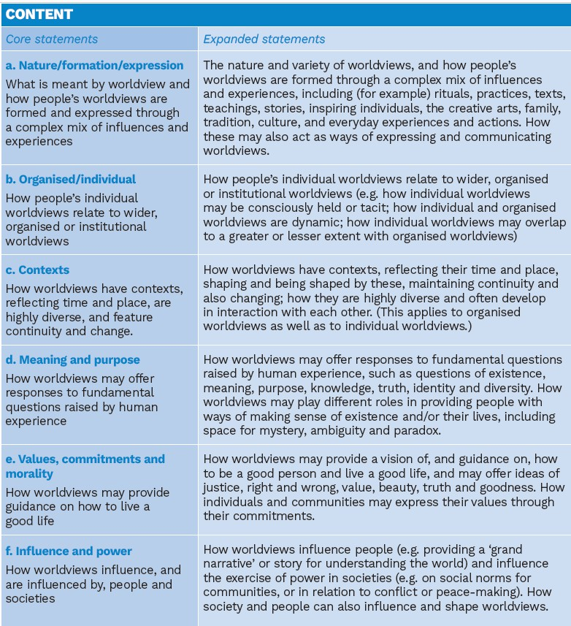
*Provisional National Statement of Entitlement (NSE)



